

MCA SEMESTER III 2013-14

Bug Tracking System

MantisBT – Project Report

Iyer Rahul Rajan

Zubin Kadva

*Under the guidance of*

Prof. Rajesh K. Maurya

**ACKNOWLEDGEMENT**

Our team has taken immense efforts in this project. However, it would not have been possible without the kind support and help of many individuals and organizations. I would like to extend my sincere thanks to all of them.

I am highly indebted to Prof. Rajesh K. Maurya for his guidance and constant supervision as well as for providing necessary information regarding the project & also for his support in completing the project.

I would like to express my gratitude towards my parents & members of Navinchandra Mehta Institute of Technology and Development for their kind co-operation and encouragement which help us in the completion of this project.

My thanks and appreciations also go to my colleagues and people who have willingly helped me out with their abilities.

|  |
| --- |
| Deccan Education Society’s  NAVINCHANDRA MEHTA INSTITUTE OF TECHNOLOGY AND DEVELOPMENT  MANTIS BUG TRACKING SYSTEM  SUBMITTED BY  Zubin Kadva Iyer Rahul Rajan  5227 5221  **2013 - 14**    Submitted to University of Mumbai  in partial fulfillment of the requirements for qualifying  MASTER OF COMPUTER APPLICATION   Examination |

**Deccan Education Society’s**

NAVINCHANDRA MEHTA INSTITUTE OF TECHNOLOGY AND DEVELOPMENT

|  |
| --- |
| **PROJECT CERTIFICATE**  This is to certify that the Project done at Navinchandra Mehta Institute Of Technology And  Development_ by Mr. ____Zubin Kadva__ and Mr. _ Iyer Rahul Rajan___________  (Roll No. ___5227___ and ___5221__ ) in partial fulfillment for MCA First Year End Project has been found satisfactory. This report had not been submitted for any other examination and does not form part of any other course undergone by the candidate.    Internal Guide Professor In-charge  College Stamp  EXAMINED BY  EXTERNAL EXAMINER ………………………………  DATE: |

Table of Contents

1. Mantis – A Case Study Report 8

1.1 Title of the project 8

1.2 Open Source Used For Further Development 8

1.3 Objectives of the Project 8

2.. Diagrams and Illustrations 10

2.1 General Perspective of a Bug 10

2.2 Bug Lifecycle in Mantis 11

2.3 Alternate Lifecycle 12

3. About The Open Source 14

3.1 What is an Open Source? 14

3.2 What is MantisBT? 14

3.3 Who should read this manual? 14

3.4 License 15

3.5 Support 15

3.6 Minor features 16

3.7 Requirements 17

3.8 Usage and Application areas 18

3.9 Future enhancement of the product 18

4. Functionalities Developed Using Open Source Software 20

5. Critical Evaluation 22

6. Design and Layout (Page descriptions) 24

6.1 Login page 24

6.2 Main page 25

6.3 My View page 26

6.4 View Issues page 27

6.5 Summary 30

6.6 Manage 31

6.7 Manage Users 31

6.8 Manage Projects Page 32

6.9 Manage Custom Fields 34

6.10 My Account Page 35

6.11 Manage Global Profiles 35

6.12 Manage Configuration 35

6.13 Email Notifications 36

6.14 Monitor Issue 37

6.16 Delete Issue 38

6.17 Close Issue 38

6.18 Assign to Me 39

6.19 Resolve Issue 39

6.20 News Syndication 40

7. Future Enhancements 42

8. Software product Received and sample report generation 44

8.1 Sample Report 45

8.2 Sample Change Log 46

8.3 Sample Roadmap 46

8.4 Sample Graphical Reports 47

8.4.1 Per State 47

8.4.2 Per Priority 47

8.4.3 Per Severity 48

8.4.4 Per Category 48

8.4.5 Per Resolution 49

8.5 Advanced Summary 49

9. Conclusion 54

10. Bibliography and References 56

List of Figures and Illustrations

Figure 1 - General Workflow 10

Figure 2 - Bug Lifecycle 11

Figure 3 - Alternate Bug Lifecycle 12

List of Tables

Table 1 - Bug Tracking System Comparison 23

Table 2 - Sample Projects 44

CHAPTER I



**Mantis – A Case Study Report**

Abstract Illustration of a Bug

## **Title of the project**

Bug Tracking System

## **Open Source Used For Further Development**

Mantis Bug Tracker

## **Objectives of the Project**

Implementing an efficient and robust bug tracking system which has various applications including the most obvious; the software industry and can also be used in institutions as a grievance redressal system which can be used by students as well as the staff or the concerned authorities. The main objective of this project is to study the overall structure of Mantis and at the same time gain an insight into the Bug Tracking Process, the actors involved in it as well as the process of reporting a bug along with the idea of how to go about resolving a bug and what to do in case a bug becomes unable to be solved or it causes further violations. Contributions to this system is also available and can be done thorough the official Mantis website[*http://www.mantisbt.org*](http://www.mantisbt.org)***.*** Thus we present to you this project report.

CHAPTER II

1. **Diagrams and Illustrations**

## **2.1 General Perspective of a Bug**

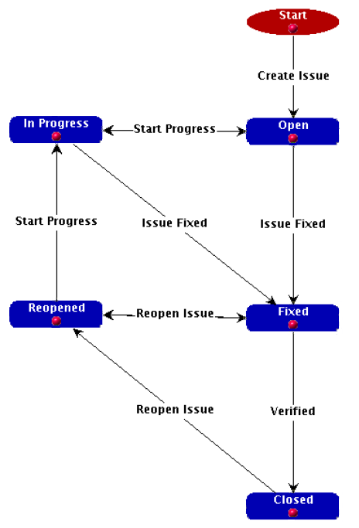

Figure - General Workflow

## **2.2 Bug Lifecycle in Mantis**



Figure - Bug Lifecycle

## **2.3 Alternate Lifecycle**



Figure - Alternate Bug Lifecycle

CHAPTER III

1. **About The Open Source**

## **3.1 What is an Open Source?**

The type of software whose code is visible to the developer (not of the software) is commonly termed as an Open Source. Thus such a software can be ‘torn apart’ and further customized and developed by writing code and placing it in the appropriate position since the necessary files are available with us.

## **3.2 What is MantisBT?**

MantisBT is a web based bug tracking system that was first made available to the public in November 2000. Over time it has matured and gained a lot of popularity, and now it has become one of the most popular open source bug/issue tracking systems. MantisBT is developed in PHP, with support to multiple database back ends including MySQL, MS SQL, PostgreSQL and DB2. MantisBT, as a PHP script, can run on any operating system that is supported by PHP and has support for one of the DBMSes that are supported. MantisBT is known to run fine on Windows, Linux, OS/2, Mac OS X, and a variety of UNIX operating systems.

## **3.3 Who should read this manual?**

This manual is targeted for the person responsible for evaluating, installing and maintain MantisBT in a company. Typically we refer to this person as the MantisBT administrator.

## **3.4 License**

MantisBT is released under the terms of GNU General Public License (GPL). MantisBT is free to use and modify. It is free to redistribute as long as you abide by the distribution terms of the GPL2.

## **3.5 Support**

There are plenty of resources to help answer support queries. Following are the main ones:

* Forums - The forums are one of the most popular destinations for getting MantisBT support. Start off by searching the forums for your questions, if not found, then go ahead and submit a question.
* Mailing lists - Available mailing lists are "MantisBT-announce" for announcements, "MantisBT-dev" for development issues, and MantiBT-lang for localization and "MantisBT-help" for general help/support questions. There are public archives for such mailing lists. Note that only members of the mailing lists can post to them, hence, subscribe to the lists before you attempt to email them.
* IRC - The IRC channel is mainly used by developers to engage in in-person discussion. The recommended tool for IRC is XChat (for Linux), XChat 2 (for Windows). However, you can also use Web Chat8 to connect to IRC via your web browser. This is also useful when your work firewall blocks the IRC port (although there are other workarounds involving tunneling to fix this issue).

Many people prefer to use IRC to ask questions to the developers and other users who are in the IRC channel.

* Wiki - The MantisBT Wiki has information related to "How To (recipes)", FAQ, feature requirements, etc.
* Search - A good way for locating an answer for your question or finding more information about a topic is to search across all MantisBT website and the Internet via Google10 or Bing11.

It is important to note that support questions should not be sent directly to MantisBT developers or through the MantisBT contact us pages. Use of "Contact Us" page or emailing the developer directly is available if you are after a paid support or consulting service.

## **3.6 Minor features**

* MantisBT also has support for:
* Full text search Audit trails of changes made to issues
* Revision control of text fields and notes
* Roadmaps
* Change logs
* Graphing of relationships between issues
* Sponsorship of issues
* Wiki documentation integration for DokuWiki, MediaWiki, TWiki, WikkaWiki and XWiki
* News
* Project Management & Time Tracking with CodevTT.
* Localized dozens of languages on translatewiki.net.

## **3.7 Requirements**

MantisBT requires a configured web server, PHP programming language interpreter and relational database management system supported by ADOdB.

The stable branch of MantisBT (version numbers within 1.1.x) requires a version of PHP greater than or equal to 4.3.0. For the preview branch (1.2.x) and development branch (1.3.x), the minimum PHP version is 5.2.0.

MantisBT bundles a number of dependencies with each release including:

* ADOdb for abstraction of support for relational database management systems
* Disposable for disposable e-mail checking functionality eZ Components for plotting of statistics NuSOAP for SOAP web service support
* PHPMailer for e-mail sending support Projax for Ajax capabilities in the user interface RSS Builder for RSS feed support PHP UTF-8 wrapper library for internationalization support in absence of PHP's mb_string extension
* For drawing graphs of relationships between issues, GraphViz is required.
* MantisBT also has an alternative dependency upon the commercial JpGraph graphics library for plotting of statistics.

## **3.8 Usage and Application areas**

As the central use of the open source suggests a bug tracker, it can be easily applied during every phase and development of a product viz. software or hardware. Apart from its uses in the software industry, the system can also find its place in universities for the sole purpose of online evaluation And at the same time, it can also be used for institutional development which can be of the form as a grievance redressal system wherein students and concerned authorities can post their problems and have it rectified.

## **3.9 Future enhancement of the product**

MantisBT presents an acceptable interface which provides ease of use and provides even a person with an acceptable level of computer knowledge to successfully use this product and accomplish the said task. However if the user does not understand its use, he/she can always refer this manual to find the appropriate solution which is further written in an easy language and does not require ant competence to accomplish the same But as the saying goes “nothing is perfect”; similarly the open source is also subject to flaws and minor irritations.

The open source can be further enhanced by providing a more attractive interface which can further help the user to do everything with ease ; thus simplifying the task even further. Also with regard to the back end interface viz. the database can further improved with regard to its structure and also improve faster access to the data items to avoid slow data transfer rate even on slower connections or incase the system in uploaded on a server with less functionalities.

CHAPTER IV

1. **Functionalities Developed Using Open Source Software**

Along with the functionalities provided by the open source, we have also included a few minor and major changes to the system.

The changes include:

* Changing the MantisBT logo accustomed to our needs
* Allowing the use of marquee which displays the latest bug or grievance
* Displaying a small flashing image which grabs the user attention to the said place
* Changing the interface by making the text bold for easier user convince and also for easier reading.
* Minor changes to the footer which appears at the bottom of every page to include our own name and other credentials which gives a new feel to the look.
* Enabled the Change Log (described above) by modifying the project attributes
* Also enabled the Roadmap (described above) feature and including a progress bar showing the amount of bugs versus the ones that have been solved.
* Installed GraphViz plugin which the enables users to view a Summary (described above) report based on various subjective criteria involving the users and the bugs that have been reported
* Email integration has also been accomplished by using Gmail as our SMTP server. With the help of this, all emails are sent using the Gmail Email service.

CHAPTER V

1. **Critical Evaluation**

The term simply means to critically evaluate a given situation or a criteria in order to simplify it and further ease of use can be provided. The theory under investigation is the Mantis Bug Tracker and the customizations and changes done to it. The Mantis Bug Tracker is effective in the sense that it provides an effective way of easily maintaining and most importantly keeping track of all the bugs that have been reported for the concerned project. It also provides a way for a graphical representation of the bugs solved versus the ones that are reported.

Mantis can be further evaluated based on the following scenario:

* Is the interface suitable in today’s modern environment?
* If changes are to be made here, are there implementation difficulties?
* How does it perform when there is limitation of hardware?
* Are there stringent security measures imposed regarding users and their passwords?

We have tried our best to overcome these shortcomings, but nothing is perfect. Therefore there are some things that need to be left as it is, since changing these values hampers the efficiency of the product. Although there are some times when we have been successful and are proud that we have accomplished a milestone.

*(For comparison between Mantis, Bugzilla and JIRA, refer to table 1)*

|  |  |  |  |  |  |  |  |  |
| --- | --- | --- | --- | --- | --- | --- | --- | --- |
| System | Creator | License | Implem-  entation  language(s) | User  interface | Back end | Dynamic  documentation  integration | Unicode  support | First  Release |
| Bugzilla | Mozilla  Foundation | MPL | Perl | Web, e-mail,  RSS, Web  service,  command line | MySQL,  PostgreSQL | reporting:  integrated  reports and  charts,  scheduled  reports by mail | ✓ | September 1998 |
| JIRA | Atlassian  Software  Systems | propriet-ary  free for  non  commercial | Java | Web, e-mail,  RSS | DB2, Firebird,  HSQLDB,  MaxDB,  Mckoi,  MySQL,  Oracle,  PostgreSQL,  SQL Server,  Sybase ASA | Atlassian  Confluence  (enterprise wiki) | ✓ | October 2004 |
| Mantis | Mantis | GPL | PHP | Web, e-mail | MySQL,  PostgreSQL,  MS SQL | ✓ | ✓ | November 2000 |

Table - Bug Tracking System Comparison

1. **Design and Layout (Page descriptions)**

## **6.1 Login page**

Just enter your username and password and hit the login button. There is also a Save Login checkbox to have the package remember that you are logged in between browser sessions.

You will have to have cookies enabled to login. If the account doesn’t exist, the account is disabled, or the password is incorrect then you will remain at the login page. An error message will be displayed. The administrator may allow users to sign up for their own accounts. If so, a link to Sign up for your own account will be available. The administrator may also have anonymous login allowed. Anonymous users will be logged in under a common account. You will be allowed to select a project to work in after logging in. You can make a project your default selection from the Select Project screen or from your Account Options. Here you can sign up for a new account. You must supply a valid email address and select a unique username. Your randomly generated password will be emailed to your email account. If MantisBT is setup so that the email password is not to be emailed, newly generated accounts will have an empty password.

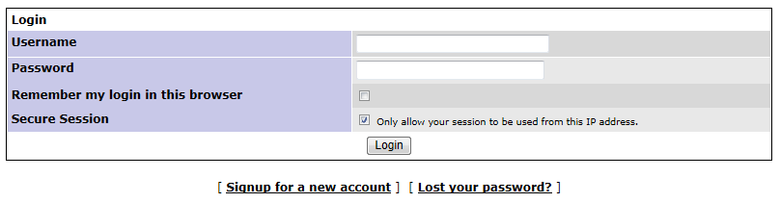

Screen - Login Page

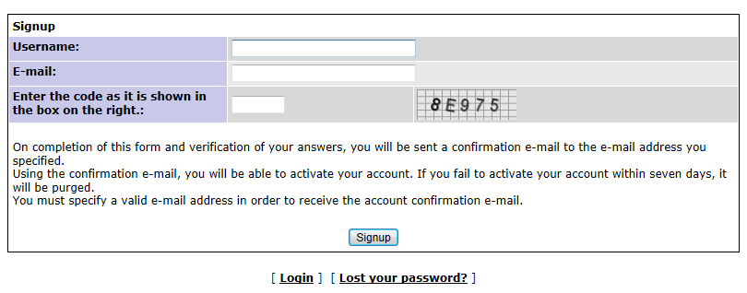

Screen - Sign up Page

* 1. **Main page**

This is the first page you see upon logging in. It shows you the latest news updates for the bug tracker. This is a simple and is to keep users abreast of changes in the bug tracker or project. Some news postings are specific to projects and others are global across the entire bug tracker. This is set at the time of posting in the Edit News section. The number of news posts is controlled by a global variable. When the number of posts is more than the limit, a link to show "older news" is displayed at the bottom. Similarly a "newer news" is displayed when you have clicked on "older news". There is an Archives option at the bottom of the page to view all listings. Archives title/date/poster listing of ALL past news articles will be listed here. Clicking on the link will bring up the specified article. This listing will also only display items that are either global or specific to the selected project.



Screen .1 - Main



Screen 3.2 - Main

## **6.3 My View page**

This is a simple page where the reported bugs appear. Each of these bugs are in a color coded format representing whether a bug is new, resolved, assigned, feedback or closed. This page also provides representations wherein the bugs can be grouped according to whether a bug is monitored or reported by the user; whether it is unassigned or resolved.

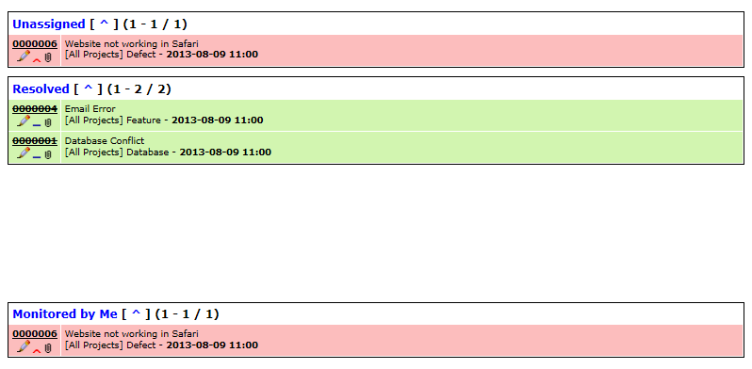

Screen .1 - My View

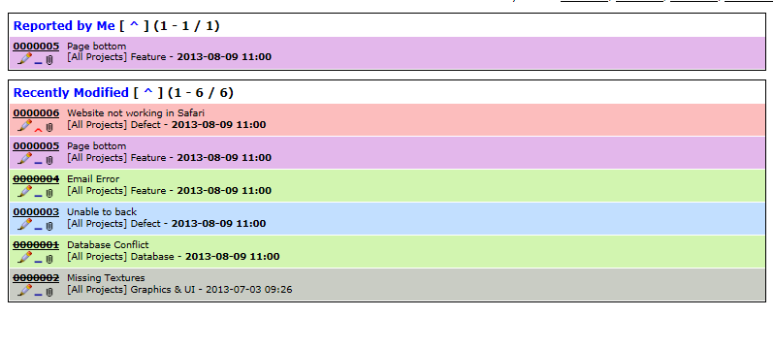

Screen 4.2 - My View

## **6.4 View Issues page**

Here we can view the issue listings. The page has a set of viewing filters at the top and the issues are listed below. The filters control the behavior of the issues list. The filters are saved between browsing sessions but do not currently save sort order or direction.

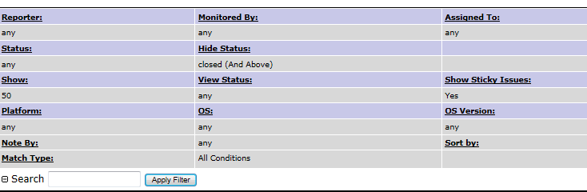

Screen - Filters

Each (except for number of issue notes) can be clicked on to sort by that column. Clicking again will reverse the direction of the sort. The default is to sort by last modification time, where the last modified issue appears at the top. The issue id is a link that leads to a more detailed report about the issue. You can also add issue notes here. The number in the issue note count column will be bold if an issue note has been added in the specified time frame.

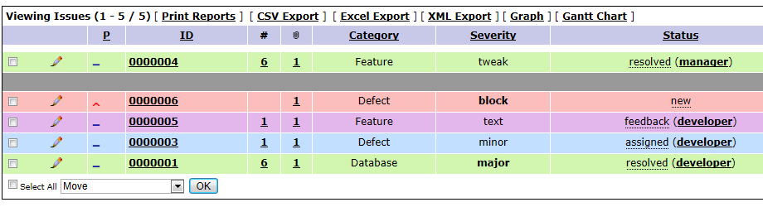

Screen - View Issues

Each table row is color coded according to the issue status. The colors can be customized through MantisBT Configuration.

*Severities*

Block - prevents further work/progress from being made

Crash - crashes the application or blocking,

Major - major issue,

Minor – minor issue,

Tweak - needs tweaking,

Text - error in the text,

Trivial – questing new feature

*Status*

New - new issue,

Feedback - issue requires more information from reporter,

Acknowledged - issue has been looked at but not confirmed or assigned, confirmed - confirmed and reproducible (typically set by an Updater or other Developer),

Assigned - assigned to a Developer, resolved - issue should be fixed, waiting on confirmation of fix,

Closed - issue is closed,

Moving the mouse over the status text will show the resolution as a title. This is rendered by some browsers as a bubble and in others as a status line text.

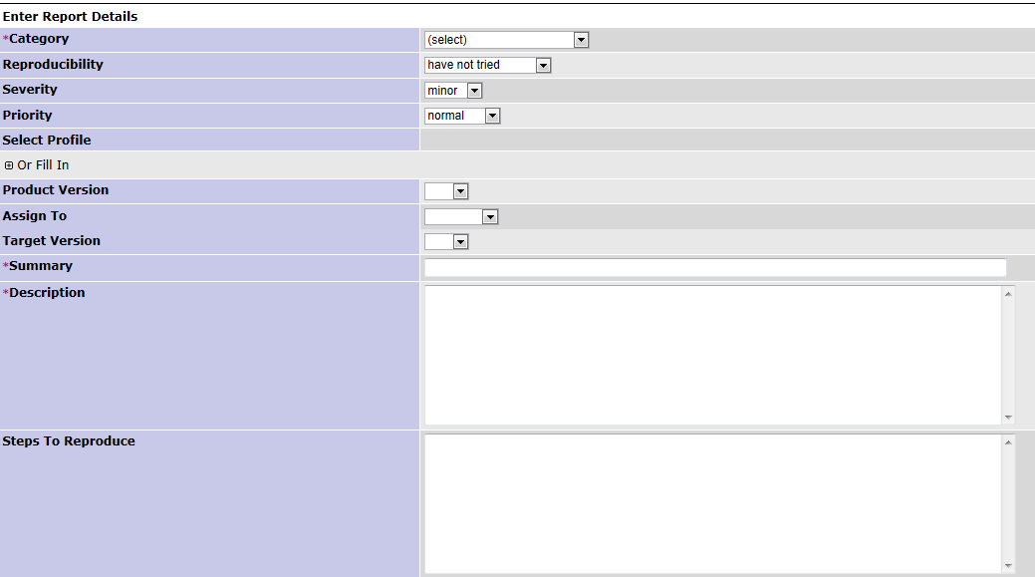

Screen - Report Issue

## **Summary**

This page provides an overview about the bugs that have been reported concerned with the appropriate project. Items here can be sorted according to categories like status, severity, date, etc.

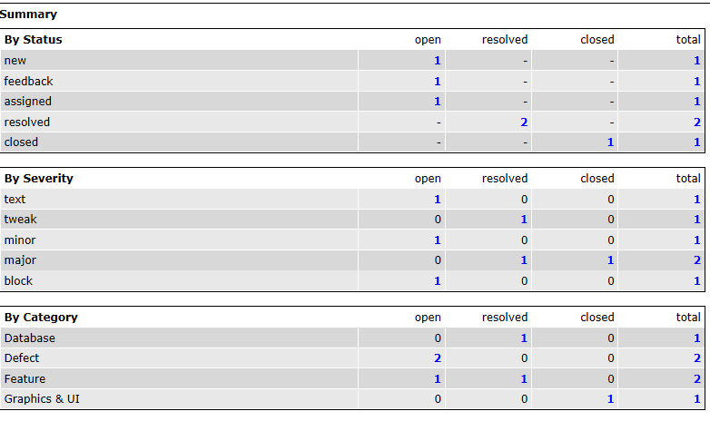

Screen .1 – Summary

This page also has the Graph plugin installed with which users can be provided with a graph like view of the data items



Screen 8.2 - Graph Summary

## **6.6 Manage**

This page required administrator privileges to access and therefore only the administrator and the manger will be allowed to access this page

However the manager will have limited privileges as compared to those of the administrator. The user has to be first authenticated to view this page

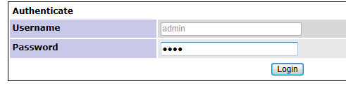

Screen - Authentication Required

## **6.7 Manage Users**

Here the administrator can manage users and also configure their accounts and other credentials. This page allows an administrator to manage the users in the system. It essentially supplies a list of users defined in the system. The user names are linked to a page where you can change the user’s name, access level, and projects to which they are assigned. You can also reset their passwords through this page. At the top, there is also a list of new users (who have created an account in the last week), and accounts where the user has yet to log in. New users are created using the "Create User" link above the list of existing users. Note that the username must be unique in the system. Further, note that the user’s real name (as displayed on the screen) cannot match another user’s user name.

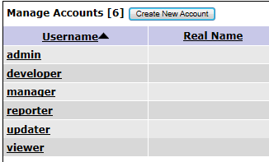

Screen - Manage Accounts

## **6.8 Manage Projects Page**

This page allows the user to manage the projects listed in the system. Each project is listed along with a link to manage that specific project. The specific project pages allow the user to change:

* the project name
* the project description
* its status
* Whether the project is public or private. Private projects are only visible to users who are assigned to it or users who have the access level to automatically have access to private projects (e.g.: administrators).
* A file directory used to store attachments for issues and documents associated with the project. This folder is located on the webserver, it can be absolute path or path relative to the main MantisBT folder. Note that this is only used if the files are stored on disk or via FTP. In case of FTP, the cached version that is saved on the webserver, is stored in the specified path.
* Common subprojects. These are other projects who can be considered a sub-project of this one. They can be shared amongst multiple projects. For example, a "documentation" project may be shared amongst several development projects.
* Project categories. These are used to sub-divide the issues stored in the system.
* Project versions. These are used to create Change Log reports and can be used to filter issues. They are used for both the Found In and Fixed In versions.
* Custom Fields linked to this project
* Users linked to this project. Here is the place where a user’s access level may be upgraded or downgraded depending on their particular role in the project.

Overall, the Mange page can be used either by administrators or managers in order to adjust the project / user attributes and perhaps the settings of the system.

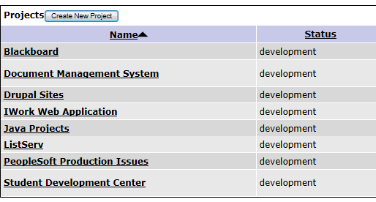

Screen - Manage Projects

## **6.9 Manage Custom Fields**

This page is the base point for managing custom fields. It lists the custom fields defined in the system. There is also a place to enter a new field name to create a new field. The "Edit" links take you to a page where you can define the details of a custom field. These include its name, type, value, and display information. On the edit page, the following information is defined to control the custom field:

* Name
* Type

The Name attribute of the custom field specifies the identity of the field and creates the corresponding column in the database.

## **6.10 My Account Page**

This page changes user alterable parameters for the system. These selections are user specific. This allows the user to change their password, screen name, and email address. It also reports the user’s access levels on the current and other projects.

## **6.11 Manage Global Profiles**

This page allows the definition of global profiles accessible to all users of the system. It is similar to the user definition of a profile consisting of Platform, OS and Version.

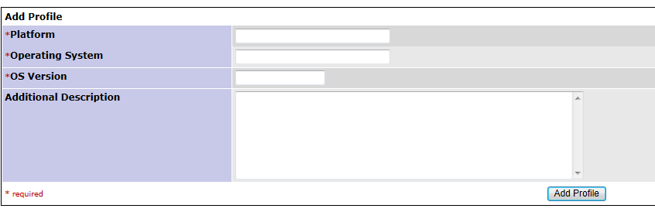

Screen - Manage Global Profiles

## **Manage Configuration**

This set of pages control the configuration of the MantisBT system. Note that the configuration items displayed may be on a project by project basis. These pages

Serve two purposes. First, they will display the settings for the particular aspects of the system. If authorized, they will allow a user to change the parameters. They also have settings for what access level is required to change these settings ON A PROJECT basis. In general, this should be left alone, but administrators may want to delegate some of these settings to managers.

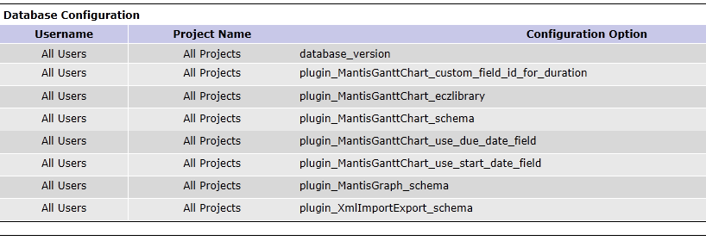

Screen - Manage Configuration

## **Email Notifications**

This page sets the system defaults for sending emails on issue related events. MantisBT uses flags and a threshold system to generate emails on events. For each new event, email is sent to:

* the reporter
* the handler (or Assigned to)
* anyone monitoring the issue
* anyone who has ever added an issue note the issue
* anyone assigned to the project whose access level matches a range

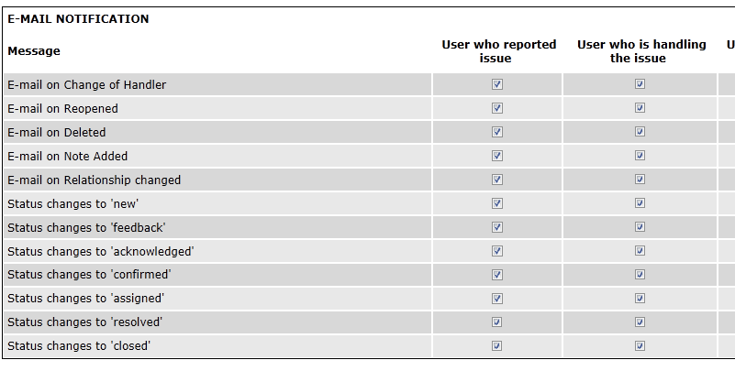

Screen - Manage Email Notification

## **6.14 Monitor Issue**

The monitor issues feature allows users to subscribe to certain issues and hence get copied on all notification emails that are sent for these issues. Depending on the configuration, sending a reminder to a user about an issue can add this issue to the user’s list of monitored issues. Users who reported the issue or are assigned the issue typically don’t need to monitor the issue to get the notifications. This is because by default they get notified on changes related to the issue anyway. However, administrators can change the configuration to disable notifications to reporters or handlers in specific scenarios.



Screen - Monitor Issue

**6.15 Reopen Issue**

Re-open issue button is visible in the issue view pages if the user has the appropriate access level and the issue is resolved/closed. Re-opening an issue will allow users to enter issue notes for the re-opening reason. The issue will automatically be put into the Feedback status.



Screen - Reopen Issue

## **6.16 Delete Issue**

The delete issues button appears on the issue view pages for the users who have the appropriate access level. This allows you to delete an existing issue. This should only be used on frivolous or test issues. A confirmation screen will prompt you if you really want to delete the issue. Updaters, Developers, Managers, and Administrators can remove issues (you can also configure this).



Screen - Delete Issue

## **6.17 Close Issue**

This is a button that appears on the issue view pages for users that are authorized to close issues. Depending on the configuration, users may be able to close issues without having to resolve them first, or may be able to only close resolved issues.

After the button is clicked, the user is redirected to a page where an issue note maybe added.



Screen - Close Issue

## **6.18 Assign to Me**

This button appears in the issue view pages in case of users with access level that is equal to handle_bug_threshold or higher. When this button is clicked the issue is assigned to the user.



Screen - Assign Issue

## **6.19 Resolve Issue**

This option on the View Issues page allows you to resolve the issue. It will lead you to a page where you can set the resolution state and a duplicate id (if applicable). After choosing that the user can choose to enter an issue note detailing the reason for the closure. The issue is then set to the resolved state. The reporter should check off on the issue by using the Close Issue button.



Screen - Change Issue Status

## **6.20 News Syndication**

MantisBT supports news syndication using RSS v2.0 protocol. MantisBT also supports authenticated news feeds for private projects or installations where anonymous access is not enabled. Authenticated feeds takes a user name and a key token that are used to authenticate the user and generate the feed results in the context of the user’s access rights (i.e. the same as what the user would see if they were to logged into MantisBT). To get access to the News RSS as anonymous user, visit the following page:

*http://<server_URL> /mantisbt/news_rss.php****.***

While a user is logged in, the RSS links provided in the UI will always provide links to the authenticated feeds, if no user is logged in (i.e. anonymous), then anonymous links will be provided.



Screen - The RSS Feed

CHAPTER VII

1. **Future Enhancements**

We believe in one line “There is always an inch more to build”. This means, the system can be enhanced, and will be enhanced further more. We were bound by certain criteria such as time, money, syllabus permission like professional talent and work experience. But positively, without these bounding criteria, we would like to enhance this software project and empower it with many more functionalities.

Some functionality our future enhancement includes.

* Inclusion of stringent security.
* Integration with the advanced web.
* User delegation
* Admin access rights
* Better Interface development
* Improving the performance
* User Delegation

Our current system is a sincere effort to balance all the current limiting criteria but we hope that we can add above functionalities to our current system.

Of course, we were constrained by the limited amount of knowledge and expertise in the concerned fields. But at the same time, we hope that this project will not be a regretted one.

CHAPTER VIII

1. **Software product Received and sample report generation**

We have included the following as our sample projects:

|  |  |
| --- | --- |
| [**Blackboard**](http://localhost/mantisbt-1.3/manage_proj_edit_page.php?project_id=3) | The central idea of this project is to have an interactive learning environment that can be useful to learning students. |
| [**Document Management System**](http://localhost/mantisbt-1.3/manage_proj_edit_page.php?project_id=11) | This system efficiently manages all the various reports, documents or files and keeps them in a repository that can be easily modified to suit the user needs. |
| [**Drupal Sites**](http://localhost/mantisbt-1.3/manage_proj_edit_page.php?project_id=4) | A number of sites built using the Drupal as a basis for open source development. |
| [**IWork Web Application**](http://localhost/mantisbt-1.3/manage_proj_edit_page.php?project_id=5) | An efficient and robust way to monitor all web applications similar to the Office(R) 365 or Google Docs(R) |
| [**Java Projects**](http://localhost/mantisbt-1.3/manage_proj_edit_page.php?project_id=6) | Sites based on the most versatile language ever. |
| [**ListServ**](http://localhost/mantisbt-1.3/manage_proj_edit_page.php?project_id=7) | Providing a listener service which can be used in a variety of applications. |
| [**PeopleSoft Production Issues**](http://localhost/mantisbt-1.3/manage_proj_edit_page.php?project_id=8) | An ERP solution that claims to solve all the trading and the commercial part of business ingenuity. |
| [**Student Development Center**](http://localhost/mantisbt-1.3/manage_proj_edit_page.php?project_id=9) | A system that serves as an effective way to easily modify the student criteria and also can be used for curriculum status of the student. |

Table - Sample Projects

***NB****: These projects are only used for illustrative purposes so that the user can confirm what kind of reports can he/she expect to receive and therefore do not form a part of the system, hence are not included. These project names will be used throughout the report section.*

## **8.1 Sample Report**

**Project -** *Document Management System;* **Bug Summary -** *Email Error*

|  |  |  |
| --- | --- | --- |
| **View Issue Details** | | |
|  | | | | | |
| **ID:** | **Category:** | **Severity:** | **Reproducibility:** | **Date Submitted:** | **Last Update:** |
| 4 | [Document Management System] Feature | tweak | sometimes | 2013-07-03 09:56 | 2013-08-09 11:00 |
|  | | | | | |
| **Reporter:** | updater | **Platform:** |  |  | |
| **Assigned To:** | manager | **OS:** |  |  | |
| **Priority:** | normal | **OS Version:** |  |  | |
| **Status:** | resolved | **Product Version:** |  |  | |
| **Product Build:** |  | **Resolution:** | fixed |  | |
| **Projection:** | none |  |  |  | |
| **ETA:** | none | **Fixed in Version:** | v1.0 |  | |
|  |  | **Target Version:** | v1.0 |  | |
| **CusotmField:** | 2013-06-09 | | | | |
|  | | | | | |
| **Summary:** | Email Error | | | | |
| **Description:** | We all are well aware that the system sends a mail to the appropriate user to inform his of the current changes or statistical information. But there seems to be a problem with sending mail for some users. I have the mail settings as  $g_allow_signup=ON;  $g_enable_email_notification=ON; $g_phpMailer_method=PHPMAILER_METHOD_SMTP; $g_smtp_host='smtp.ourerver.com'; $g_smtp_username='[xxxx@xxxx.com](mailto:xxxx@xxxx.com)'; $g_smtp_password='xxxxx'; $g_smtp_connection_mode='tsl'; $g_smtp_port=25;  Need some help here. | | | | |
| **Steps To Reproduce:** |  | | | | |
| **Additional Information:** |  | | | | |
| **Attached Files:** | issue001.jpg (54,364) 2013-07-03 09:56 http://localhost/mantisbt-1.3/file_download.php?file_id=5&type=bug | | | | |

Screen - Sample Report

## **8.2 Sample Change Log**

**Project -** *Document Management System*

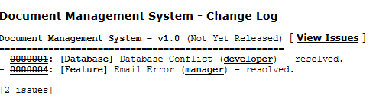

Screen - Sample Change Log

## **8.3 Sample Roadmap**

**Project** - *Document Management System*

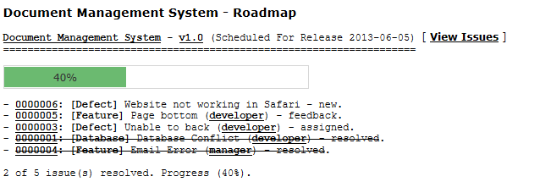

Screen - Sample Roadmap

## **8.4 Sample Graphical Reports**

**Project** - *Document Management System*

## **8.4.1 Per State**

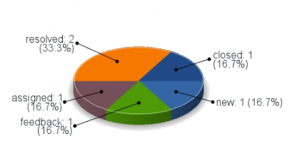

Screen .1 - Graph

## **8.4.2 Per Priority**

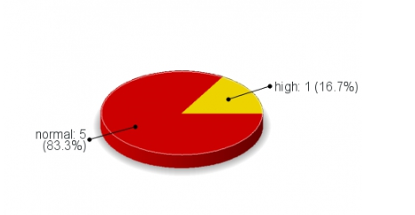

Screen 25.2 - Graph

## **8.4.3 Per Severity**

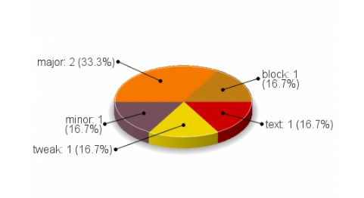

Screen 25.3 – Graph

## **8.4.4 Per Category**

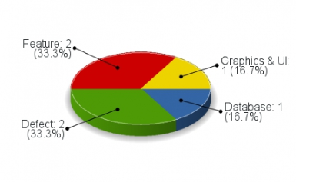

Screen 25.4 – Graph

## **8.4.5 Per Resolution**

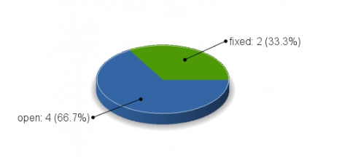

Screen 25.5 - Graph

## **8.5 Advanced Summary**

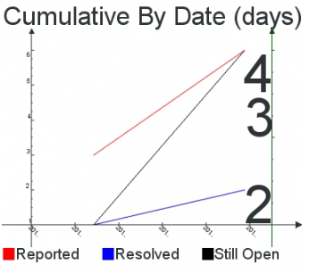

Screen .1 - Graph

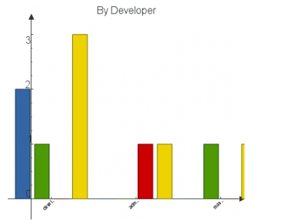

Screen 26.2 – Graph

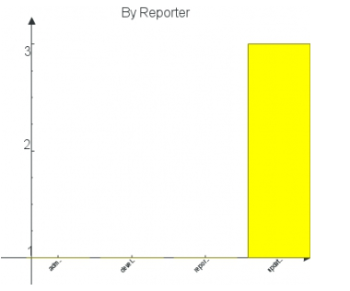

Screen 26.3 – Graph

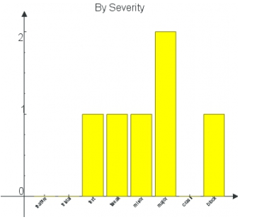

Screen 26.4 - Graph

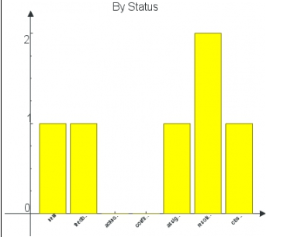

Screen 26.5 - Graph

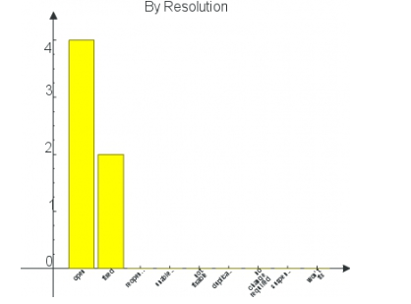

Screen 26.6 – Graph

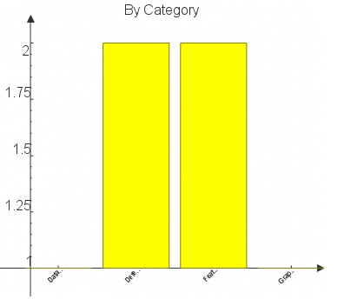

Screen 26.7 – Graph

CHAPTER IX

1. **Conclusion**

Working with this project has increased my knowledge about advanced programming. At the same time it has also improved my ability to look at things differently thus helping me to understand the methodology and the programming style adopted to create these wonderful programs. As for the database structure, I have also understood the main purpose of a relational DBMS. Each database table clearly depicts its relation with other tables in the system, also I have understood the various queries fired for obtaining the required data items and also the code for connectivity.

In conclusion, this project can have a implementations in not only the software industry but also in a plethora of institutions and a variety of applications, where a strict check needs to be kept on the maintenance and other issues, thus such an application can be used under such circumstances.

We would also like to extend our support to the MantisBT development team for providing the basis for our study and therefore made this project successful. Also the MantisBT forum has been helpful in understanding its code and making the appropriate changes to suit our needs.

CHAPTER X

1. **Bibliography and References**

* The Mantis BT Manual (v.1.2.x) [*2010*] [*http://www.mantisbt.org*]
* The Mantis BT Wiki [*2010*] [*http://www.mantisbt.org*]
* User testimonials [*2012*] [*http://www.mantisbt.org*]
* User directory [*2013*] [*http://www.mantisbt.org*]
* The Mantis BT Guide for developers’ [*2013*] [*http://www.mantisbt.org*]
* Administrative Guide [Bug Tracking Systems] [*http://www.github.org*]
* Working with Mantis Extensions [2012] [*http://www.github.org*]
* Mantis Development Guide [2013] [*http://www.mantisdevelopment.com*]
* Mantis Collection Dev [2013] [*http://www.mantiscollection.com*]